|  |  |  |  |
| --- | --- | --- | --- |
| \\lyng-dc1\StaffShared\Learning Bugs Animals ALL subjects\characters bugs animals\Cyril the Snail - History.jpeg**Lyng Primary School Knowledge Organiser** | | | |
| **History Topic:** | **The Vikings - Were the Vikings really**  **savage and barbaric**  **invaders?** | Year 6  *Civilisation, Communication and Inventions* | Autumn 1 |

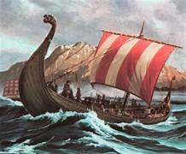

**Background information for teachers and parents.**

The Viking Age in Britain began about 1,200 years ago in the 9th Century AD and lasted for just over 200 years. The Vikings came across the North Sea, just as the Anglo-Saxons had done 400 years earlier. In time, like the Anglo-Saxons, the Vikings made their home here. This topic builds on the Year 4 topic, but focusses on how the Anglo-Saxons and Vikings settled in Britain as well as the settlements the Vikings left behind in Scandinavia. We will also look at why the monastery at Lindisfarne was so vulnerable to attack.

|  |  |
| --- | --- |
| **What Step On and Goldilocks words will I use?** | |
| **Spelling** | **Definition** |
| Archipelago | An extensive group of islands. |
| Barbarian | A member of a people not belonging to one of the great civilizations (Anglo-Saxon/ Viking captives). |
| Danelaw | The Eastern area of England ruled by the Vikings. |
| Fjord | A long, narrow, deep inlet of the sea between high cliffs, as in Norway. |
| Flee/fled | To run away from danger. |
| Hebrides | A small group of islands of the coast of Scotland. |
| Hoard | Collection of Viking treasure. |
| Invade/ Invasion | • To attack.  • To enter with the intention to take over. |
| Jorvik | The Viking name for York (in North East England) |
| Long ship | Transport used by Vikings between Scandinavia and Britain. |
| Monarch | King or Queen. |
| Monastery | A building where monks live, work and pray. |
| Pillage | Steal something using violence. |
| Plunder | Steal from a place. |
| Voyage | A long journey involving the sea. |

|  |  |
| --- | --- |
| **When? (Timeline of key events)** | |
| 793 | Raids of monasteries, including Lindisfarne |
| 865 | Great Viking army from Denmark invaded England. |
| 866 | Danes captured York (which the Vikings called Jorvik) and made it their kingdom. |
| 876 | Vikings from Denmark, Norway and Sweden settled permanently in England. |
| 886 | King Alfred ‘the Great’ defeated the Vikings but allowed them to settle in Eastern England Beginning of Danelaw 927 |
| 927 | The kingdoms of England were united by King Æthelstan  Wessex ruled the other kingdoms |

**Hook - Battle of Lindisfarne (LOTC)**

Re-create the battle in the forest

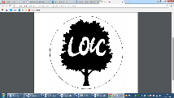

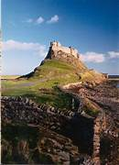

c



**TRIP/VISITOR**

**Viking Visitor - September**

The Völsunga saga– “

“Better to fight and fall than to live without hope.” without hope.”

**Great Quotes**

**Our Storytelling Approach to enhance engagement**

|  |  |  |
| --- | --- | --- |
| **People:**  A picture of Vikings in NorwayNorse boy (in training to be a Viking) | **Place:**  Norway to Lindisfarne  C:\Users\mia.wallace\AppData\Local\Microsoft\Windows\INetCache\Content.MSO\AFBE227A.tmp | **Problem:**  Voyage from Norway to settle in Britain because of the lack of farming space on the western coast of Norway, the Vikings were obliged to set sail for new lands to find better soil. While the basis of many Viking raids was to plunder, they often had the motivation to set up colonies and kingdoms in which they could farm. |

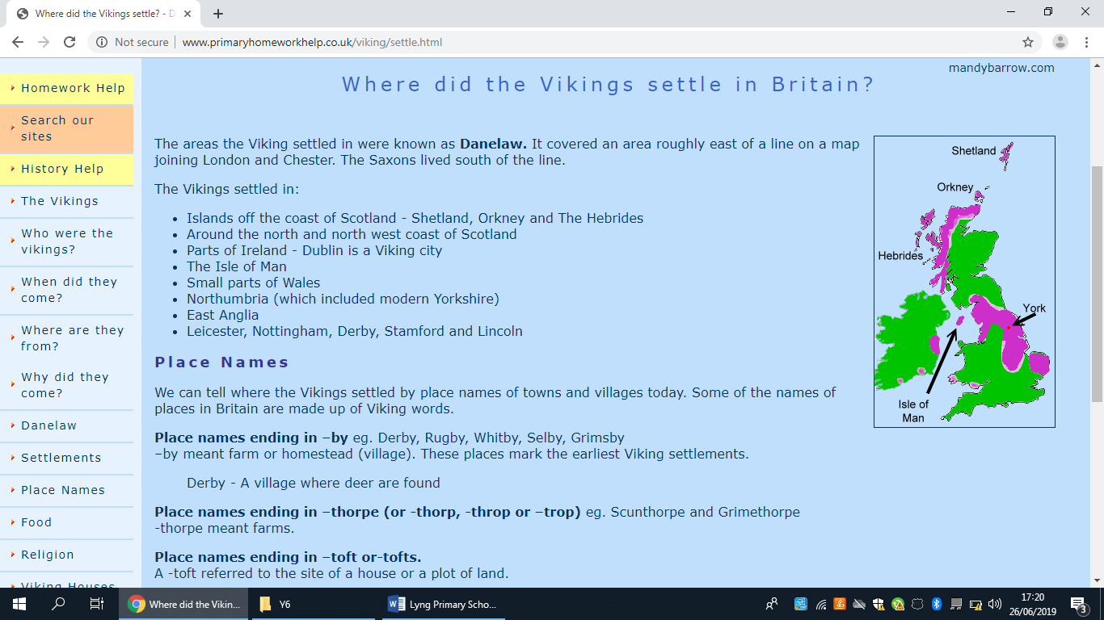

**Focus Text**

**Key Facts and Famous Figures**

|  |  |  |
| --- | --- | --- |
| Norway | Weaponry and Travel | Settlement |
| * Norsemen weren’t just barbaric, axe-wielding invaders. * Vikings also created complex social institutions, oversaw the coming of Christianity to Scandinavia. * Vikings ruled in Norway is from around 800 to 1066. * There were around nine minor kingdoms that occupied much of the Viking territory. * In 900s, Harald Fairhair came along and was able to unite the country (by battling or bribing anyone who opposed him), creating the first Norwegian state. * Much of the population [lived in coastal areas to farm and fish](https://www.lifeinnorway.net/viking-lifestyle/). * The largest centre of population at the time was at Skiringssal, located in what is now Huseby, which was home to around 500 Norsemen. | * The most expensive weapon was the sword, as it took the most iron to make. * Most Viking men carried axes or spears. Battle axes had long handles, were light, well balanced and deadly. * All Viking men would carry a round shield for protection. The status of a Viking was determined by the quality of his defensive weapons. * The Vikings were capable sailors and this enabled them to travel widely. Their ships were highly advanced and, in particular, the progress made in the use of the sails was of great significance. * The ships of the Vikings were the key to their success. * Their long, narrow shape made them quick in water, but also meant a very limited capacity for cargo. | * The areas the Viking settled in were known as Danelaw. It covered an area roughly east of a line on a map joining London and Chester. The Saxons lived south of the line. * The Vikings settled in: * Islands off the coast of Scotland - Shetland, Orkney and The Hebrides * Around the north and north west coast of Scotland * Parts of Ireland - Dublin is a Viking city * The Isle of Man * Small parts of Wales * Northumbria (which included modern Yorkshire) * East Anglia * Leicester, Nottingham, Derby, Stamford and Lincoln |

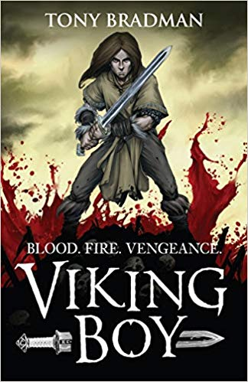

* **When and why did the Vikings come to Britain?**
* **Were the Vikings raiders, traders or something else?**
* **What were the impacts of Viking raids on Britain?**
* **How did Viking invasions impact on communities?**
* **Was 'Alfred the Great' really great?**
* **How did the Anglo-Saxon and Viking era end?**
* **What were the Vikings’ achievements and how did they impact the world?**

**Enquiry questions that we shall investigate during the topic:**

**Agreed Outcome**

A diary entry of a young Viking and also a monk under attack at Lindisfarne.

|  |  |  |  |
| --- | --- | --- | --- |
| \\lyng-dc1\StaffShared\Learning Bugs Animals ALL subjects\characters bugs animals\Cyril the Snail - History.jpeg**Lyng Primary School Knowledge Quiz** | | | |
| **History Topic:** | **The Vikings - Were the Vikings really**  **savage and barbaric**  **invaders?** | Year 6  *Civilisation, Communication and Inventions* | Autumn 1 |

|  |  |  |
| --- | --- | --- |
| 6. A settlement is... | **S** | **E** |
| Sorting out an argument |  |  |
| A place where people establish a community |  |  |
| An area specific for hunting |  |  |

|  |  |  |
| --- | --- | --- |
| 7. Why did the Norsemen leave Scandinavia? | **S** | **E** |
| Not enough good land for everyone to share |  |  |
| Fell out with their wives |  |  |
| Needed a change of scenery |  |  |

|  |  |  |
| --- | --- | --- |
| 1. How did the children demonstrate that they were ready to be a Viking? | **S** | **E** |
| Start: End: | | |

|  |  |  |
| --- | --- | --- |
| 1. Why couldn’t the monks retaliate? | **S** | **E** |
| Couldn’t afford a Battle-Axe |  |  |
| Their religion prohibited them |  |  |
| They weren’t trained |  |  |

|  |  |  |
| --- | --- | --- |
| 1. Why were the Shetland Islands a good place to settle | **S** | **E** |
| Start: End: | | |

**Our Viking**

**Quick Quiz**

|  |  |  |
| --- | --- | --- |
| 1. Which country is in Scandinavia? | **S** | **E** |
| 1. Shetland Islands |  |  |
| 1. Norway |  |  |
| 1. Spain |  |  |

**Start of topic___**

**End of topic___**

|  |  |  |
| --- | --- | --- |
| 1. What year was the invasion of Lindisfarne? | **S** | **E** |
| 793 AD |  |  |
| 739 AD |  |  |
| 793 BCE |  |  |

|  |  |  |
| --- | --- | --- |
| 1. Give an example of a Viking language | **S** | **E** |
| Start: End: | | |

|  |  |  |
| --- | --- | --- |
| 1. Somebody who studies the past by exploring old ruins is called... | **S** | **E** |
| Archaeologists |  |  |
| Settler |  |  |
| Invader |  |  |



|  |  |  |
| --- | --- | --- |
| 1. Which sea divided Britain and Scandinavia? | **S** | **E** |
| A cold one |  |  |
| The North Sea |  |  |
| Baltic Sea |  |  |